**Jenkins CI CD pipeline for flask application**

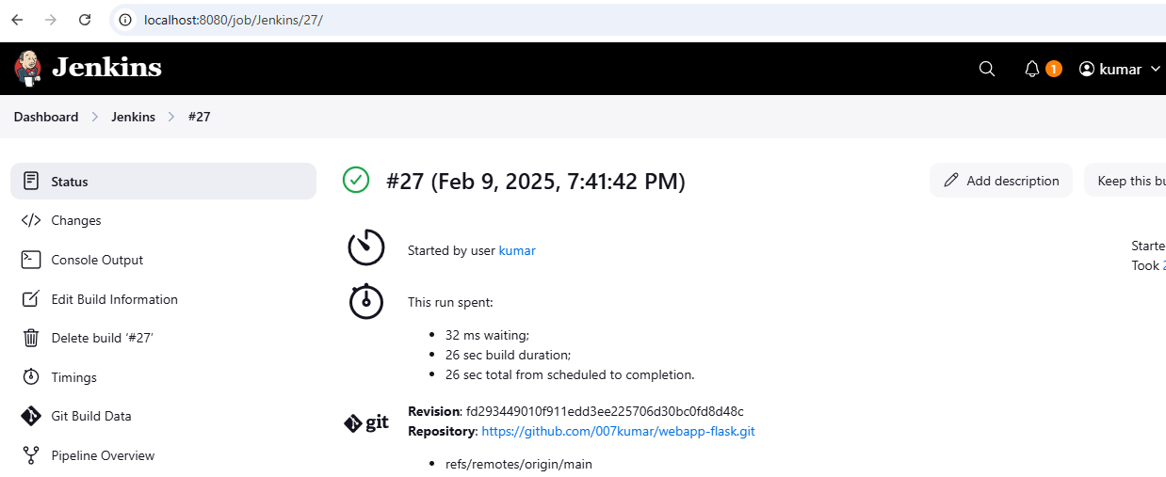

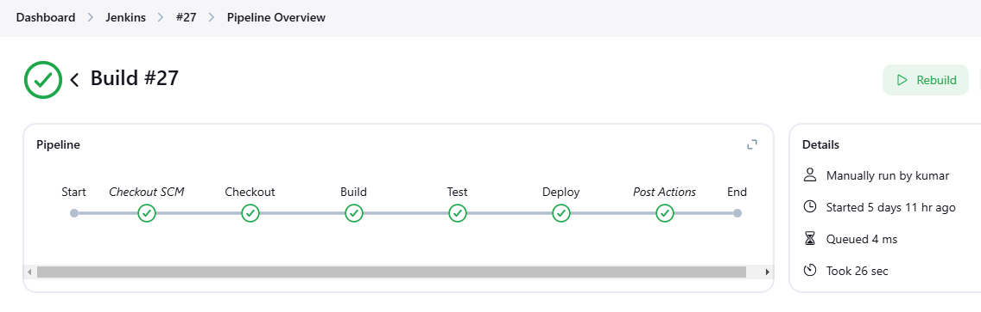

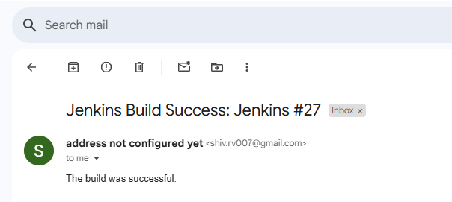

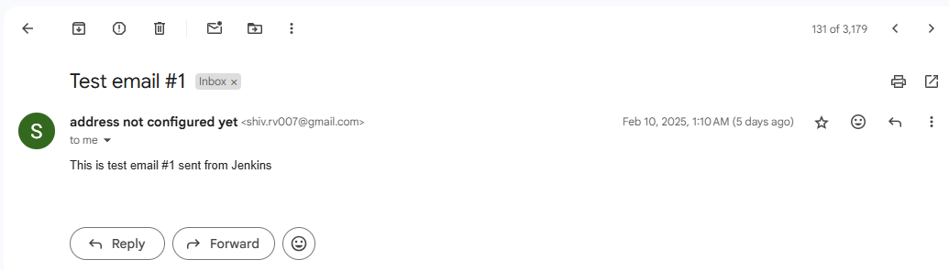

GIT HUB CI CD

https://github.com/007kumar/git-CICD-flask.git